**EXPERIMENT: 20**

**IMPLEMENTATION OF IOT BASED SMART GARDENING**

**Aim:** To implement IOT based smart gardening using Cisco packet tracer.

Software/Apparatus required: Packet Tracer/End devices, Hubs, Connectors.

Procedure:

**Step 1**: Create a new project in Cisco Packet Tracer and drag a generic IoT device from the IoT devices section onto the workspace.

**Step 2**: Right-click on the IoT device and select Config/Attributes.

**Step 3**: In the Configuration tab, select the device's IoT server from the drop-down list. You can choose Cisco IoT Cloud or another cloud service of your choice.

**Step 4**: In the Attributes tab, add the following attributes:

• Temperature

• Humidity

• Soil Moisture

• Light Intensity

**Step 5:** Create a soil moisture sensor and a light sensor from the Sensors section of the devices panel. Drag and drop these sensors onto the workspace.

**Step 6:** Connect the sensors to the IoT device using the wiring tool.

**Step 7:** Configure the sensors by right-clicking on them and selecting Config/Attributes. Set the sensor type, unit of measurement, and other necessary parameters.

**Step 8:** Create a water pump and a light bulb from the Actuators section of the devices panel. Drag and drop these actuators onto the workspace.

**Step 9:** Connect the actuators to the IoT device using the wiring tool.

**Step 10:** Configure the actuators by right-clicking on them and selecting Config/Attributes. Set the actuator type, command, and other necessary parameters.

**Step 11:** Save the configuration and run the simulation to test your IoT Smart Garden.

**Step 12:** Monitor the temperature, humidity, soil moisture, and light intensity readings on the IoT device dashboard.

**Step 13:** Use the dashboard to control the water pump and light bulb based on the sensor readings.

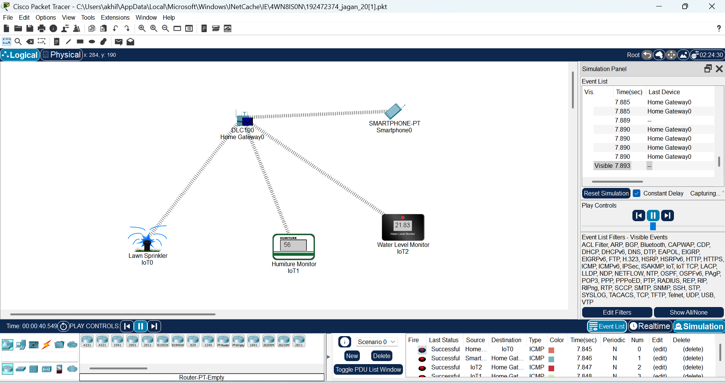

**Result**: Implementation of smart gardening is carried out using IOT successfully.